**Big data Analytics**

# **CS5590BD**

**Lab-2 Assignment**

BY

L V SANDEEP, BATHINA (16174348)

Task1: Application on sensor tag

* **Subtask1 :  Implement an application to generate a file for 4 activities**

**Steps:**

1. Import and Run the given application by doing some slight modifications in the code.

This code runs for following activities:

1. Accelerometer
2. Geo Location
3. Data
4. Humidity

The code looks as follows:

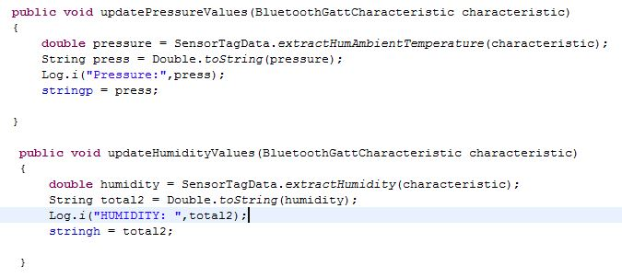

1. Run the application on Nexus phone as follows.

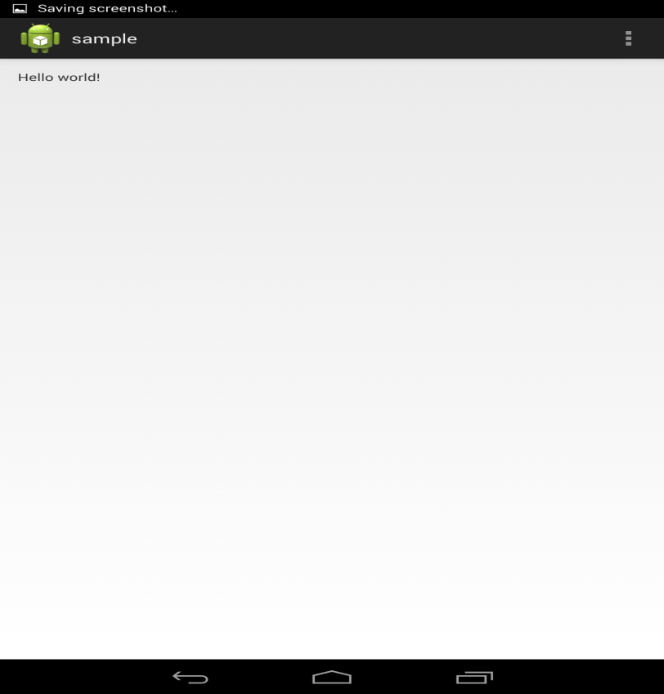

1. The file generated in the phone is sensor_group6.txt as follows in Astro file manager:

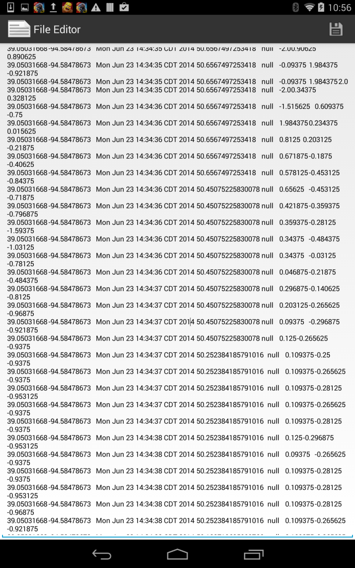

1. Generated file content is:

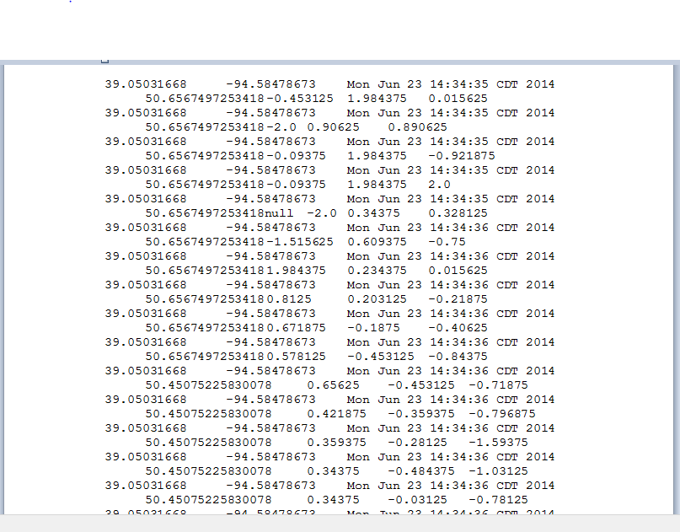

Task 2: hbase data insertion

* **Subtask 1: Inserting data to HBase**

**Steps:**

1. Imports the HBase updated source code to the eclipse and do the code modifications as below.

Now the code looks like:

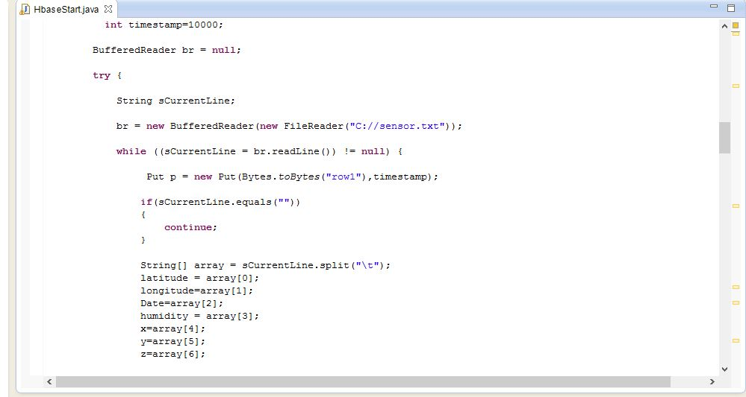

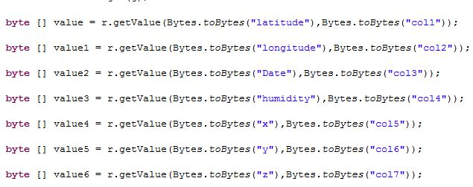

1. Before running the application, connect to the UMKC VPN.
2. Now run the Java application for creating the table.

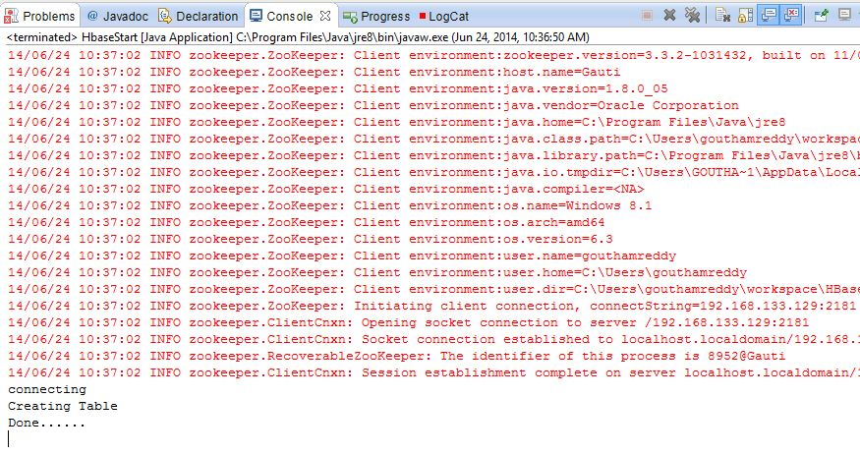

1. After creating the table, Sensor_group6.txt file information which got generated from application will get inserted in to that table.
2. After Inserting, now we can retrieve all the information present in that table. The Information will be related to Geo location, accelerometer, Date and humidity

